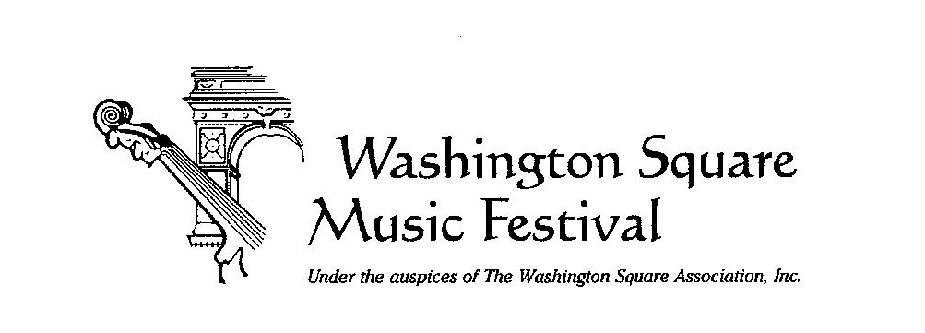

Info: washsqmusicfest@gmail.com

WASHINGTON SQUARE MUSIC FESTIVAL RINGS IN THE HOLIDAYS
on Sunday, Dec. 7th, 4 pm FREE
The Washington Square Music Festival Rings in the Holidays and wraps up its 67th season on Sunday, December 7 at 4 pm in St. Mark’s Church-in-the-Bowery. Music Director Ahmed Alom conducts the Festival Chamber Orchestra in a program of French composers, Mozart, and a Bulgarian folk song. The concert is free; seating is first-come, first-served.

Impressions françaises
Festival Chamber Orchestra, Ahmed Alom, conductor
St. Mark’s Church-in-the-Bowery
131 East 10th Street
New York, NY 10003
ws-mf.org
Maurice Ravel (1875–1937)
Rapsodie espagnole (for four hands)
Ahmed Alom & Juan Lázaro, piano
Darius Milhaud (1892–1974)
La création du monde, Op. 81a
- Introduction
- The Chaos before Creation
- The Creation of Man and Woman
- Desire
- The Dance of Man and Woman
Jules Demersseman (1833–1876)
Fantaisie for Saxophone and Chamber Orchestra
José Antonio Miranda, saxophone
Traditional (arr. Ahmed Alom, b. 1998)
Kalimankou Denkou – Bulgarian Folk Song for String Orchestra
Wolfgang Amadeus Mozart (1756–1791)
Piano Concerto No. 23 in A Major, K. 488
- Allegro
- Adagio
- Allegro assai
Juan Lázaro, piano
Ahmed Alom is a pianist, composer, and conductor whose artistry bridges classical and popular traditions, earning him recognition as “one of the most versatile artists in the Western Hemisphere” (Diario de Mallorca). His compositions have been performed by leading musicians, including Yuja Wang, who premiered his Displaced Etude No. 1 at the New York Philharmonic. As a soloist, Alom has appeared with the Baltimore Symphony Orchestra, Indianapolis Symphony Orchestra, Louisville Orchestra, New World Symphony, and Orquesta Filarmónica de México, among others. He is the youngest Music Director of the Washington Square Music Festival, where he champions inclusive and innovative programming.
Juan Lázaro is a New York-born pianist of Peruvian/Russian descent. He made his concert debut at the age of six. In 2006, Juan entered the Mannes College Preparatory Division. He has given numerous solo and collaborative recitals at venues including Steinway Hall, Musikverein, Yamaha Hall, Weill Recital Hall, Bruno Walter Auditorium, and the Metropolitan Opera's Liszt Hall. In 2015, Lázaro graduated from the Juilliard School with a Bachelor of Music degree. In 2019, he graduated with an MA in Collaborative Piano (with a focus on voice) from the Manhattan School of Music. In 2022, Lázaro was admitted to the Lindemann Young Artists Program at the Metropolitan Opera. He recently served as assistant conductor and diction coach for the Met’s new production of Ainadamar by Oswaldo Golijov.
The Washington Square Music Festival is made possible with public funding from the New York City Department of Cultural Affairs and the New York State Council on the Arts with the support of Governor Kathy Hochul and the New York State Legislature. Generous grants from the New School, The Washington Square Association, The Margaret Neubart Foundation Trust, New York University Community Affairs & NYU Community Fund, Salamon-Abrams Family Fund, and the Washington Square Park Conservancy are deeply appreciated, as is invaluable help from NYC Parks and Recreation.

